HACETTEPE UNIVERSITY
Department of Computer Engineering

Fuzzy Modelling
Laboratory

Furkan Simsekli
5th Semester
Turkey

Academic Year 2023/2024

Exercise 8

Design a fuzzy controller. The controller has one input and one output. The range of changes for the input signal is ZX and for the output signal is ZU.

The changes of the input signal are described using five Gaussian membership functions. The changes of the output signal are described using linear functions with the following parameters NN [0 -1], N [0 -0.5], Z [0 0], P [0 0.5], PP [0 1]. The modal values of the Gaussian membership functions are equal: x_{m1}, x_{m2}, x_{m3}, x_{m4}, x_{m5}.

The rule base contains three rules:
R1: IF x is NN THEN u is NN
R2: IF x is N THEN u is N
R3: IF x is Z THEN u is Z
R4: IF x is P THEN u is P
R5: IF x is PP THEN u is PP

Determine the change in the characteristics of the controller for the following height of the intersection of the input membership function h_{1X} , h_{2X}.

Show in the graphic form:
- the model of the controller,
- the input Gaussian membership functions,
- the output membership functions,
- the rule base,
- the characteristics of the controller

ZX = [-6, 6]

x_{m1} = -4 x_{m2} = -2 x_{m3} = 0 x_{m4} = 2 x_{m5} = 4
h_{x1} = 0.25 h_{x2} = 0.75

Solution

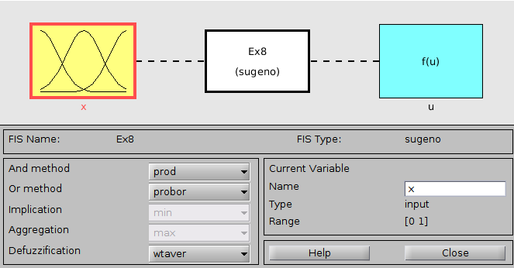
Figure 8.1: The model of the controller

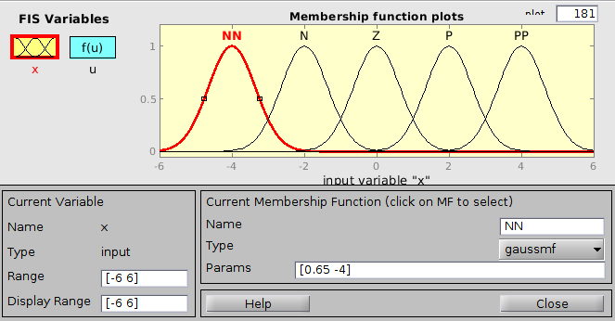
Figure 8.2: The input Gaussian membership functions for h_{x2} = 0.25

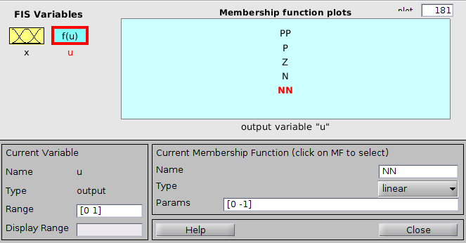
Figure 8.3: The output membership functions

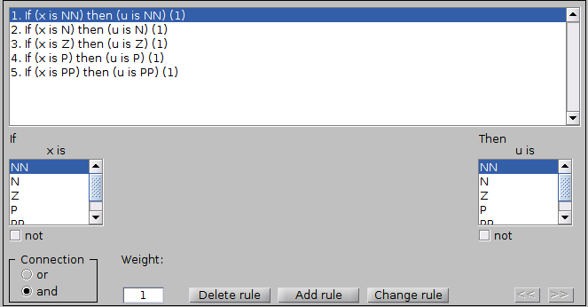
Figure 8.4: The rule base

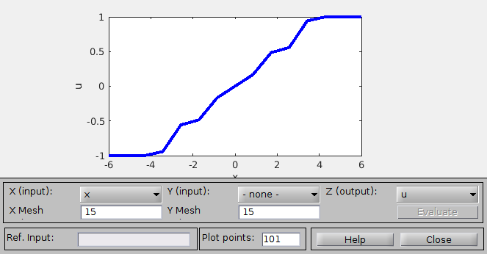
Figure 8.5: The characteristics of the controller for h_{x2} = 0.25

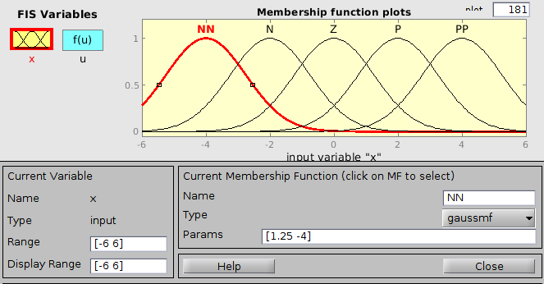
Figure 8.6: The input Gaussian membership functions for h_{x2} = 0.75

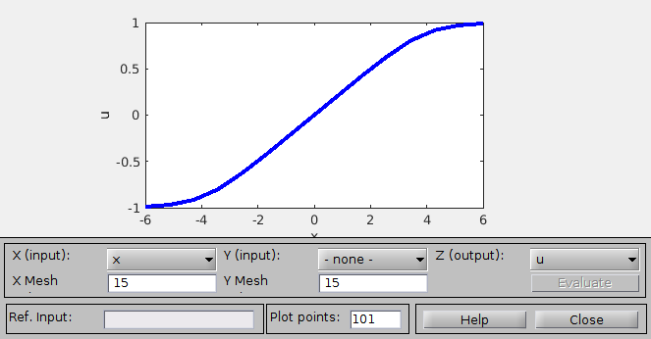
Figure 8.7: The characteristics of the controller for h_{x2} = 0.75

